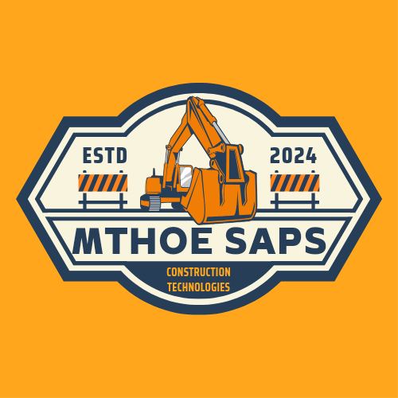

**Geospatial Data Web App Project Research Progress Documentation**

Project Research Development

1. 19-12-2023: First commercial drone flight to test out drone mapping and surveying techniques.

2. 08-01-24 to 09-01-24: Research initiated on drone sensor systems. Purchase of drone sensors such as the Infrared sensor(IR sesnor), Passive Infrared Sensor (PIR Sensor) ad also the Ultrasonic sensor in order to begin test coding as well as microcontrollers like the Arduino Uno R3.(Purchase of test hardware for rigorous bench testing)

3. 13-01-2024: Successfully completed sensor research and succesfully prototyped first sensor board (Phase 1 of research complete)

4. 16-01-2024: Begun research on geospatial web applications comparing to how international data scientists design and create web apps that interpret datasets and databases to visually intrprettable graphs, charts as well as maps. Research was also based on advanced Geo Location, Geo Tracking and Geo Mapping techniques (based on fundamentals on Advanced GIS techniques such as drone mapping). Techniques are adapted to other technologies such as Unmanned Aerial Vehicles (UAV’s).

5. 27-01-24: Reserach complete, advanced to next stage which was to build our geospatial data web app that would simulate rela time data and datasets.

6. 25-03-24: Phase 2 complete, succesfully built a powerful geospatial data tool. The tool has surpassed its original capabilities and it has now some advanced features showing the rapid progress made in the research. Research has advaced beyond planned stage as we have now reached 3d visualisation of Graphs and Mapping.

7. N/A: Project has reached final stage which funding and deployment of project in the real world to work on real life projects in Zimbabwe. Begin beta project to sign first five (5) companies into the project. Currently undertaking a new build of the City of Bulawayo map.

Project Capabilities:

1. Able to convert excel, csv, json files (any type of dataset or database) in to visually and graphically interpretable charts, graphs and maps.

2. Able to send drones on autonomous missions (simulated flights).

3. Able to perfom 3D drone land surveys.

4. Able to analyze, manipulate and interpret alot of data patterns.

Project Research Funding Requirements:

1. DJI Mavic Pro 3 drone $___________

2. 3D LiDAR sensor for drone mapping $____________

3. GPS or GNSS reveiver/ transmitter $____________, Quantity=_________

MARKET RESEARCH

PRODUCT 1: SOFTWARE DEVELOPMENT SERVICES

Here we will develop ad deploy a geospatial as well as a property management software for each affiliated company or organisation that are fully interactive and meet and fulfill the needs of the clients.

PRODUCT 2: DRONE LAND SURVEYS AND MAPPING, GIS REMOTE SENSING

Here we will offer 3D drone land survey and mapping services. As stated, original beta project companies will get three free land survey and mapping projects of their choice and lifetime loyalty rewards that will cut all their future project costs by 50%.

Customers:

1. Reals Estate and Construction firms (land development companies)

2. Architects

3. Land Surveyors and Quantity Surveyors

4. Civil and Structural Engineers

5. Bulawayo City Council and other similar bodies

7. Government and other similar policiy making bodies

8. General civilians looking for development assistance

Competitors:

Contracting land surveying firms and technovative companies that develop similar software.

Gaps that competitors have not fulfilled:

(i) Performing drone sensor fusion for land surveys.

(ii) Developing custom software that can interpret and visualize excel, csv type datasets to graphically usable data.

(iii) Developing custom software that meets the exact needs of the client and can be tailored anytime depending on the job requirements meaning software is able to handle large and robust databases and datasets.

(iv) Breaking the barriers of land survey i Zimbabwe, this system is less labor intensive, and less time consuming. The main aim of our project is to be able to accurately draw new maps of Bulawayo (and Zimbabwe over if the project exceeds beta testing) in a short amount of time and to be able to complete property surveys in less than 72 hours including documentation and a full report of the survey.

(v) Create learning based employment for drone programming enthusiasts: the project looks to adopt people who have a similar passion for drone programming and building custom softwares, this would help Bulawayo keep up with the latest technological trends in the world to solve complex problems in the Built Environment and help bridge the gap in the use of technology by the world reat estate and land survey companies as well as Bulawayo real estate and land developemt companies.

PRODUCT COSTING:

(a)Product Costing for Beta programme companies:

Beta project joining fee: USD $500.00

Beta project monthly charge: USD $75.00

(b)Beta project companies costing after beta testing(first 12 months):

Survey costs: 50% off all surveys

Beta project monthly charge: 50% off set monthly charge

(c) Costing for non-beta project companies, organisations, individuals:

PRODUCT 1 Costing (Software development services):

Geospatial Web App premium cost: USD $380.00

Geospatial Web App monthly charge: USD $80.00

Property Managemet Web App premium cost: USD $380.00

Property Management Web App monthly charge: USD $80.00

Combined Package premium cost: USD $620.00

Combined Package monthly charge: USD $135.00

PRODUCT 2 Costing(Drone Land Surveys and GIS Remote Sensing Surveys):

Survey cost: Depends on project type but base cost is $980.00 survey of a 10 000 square meter property.